Position Paper on Opioid Epidemic

The Junior Leagues of New Jersey State Public Affairs Committee (SPAC) is a non-partisan committee comprised of representatives from the eight Junior Leagues across New Jersey. SPAC advocates for evidence-based initiatives (prevention, education, treatment and recovery) and legislation to combat the opiate epidemic impacting citizens throughout the state – primarily our adolescents, teens, and young adults.
BACKGROUND: According to the CDC, the number of deaths due to drug overdose has been on a steep rise since 1996, and opioids (both illicit and prescription) are the main driver of the rise in deaths and have surpassed car accidents as the leading cause of accidental death. In 2015, over 30,000 deaths alone were attributed to opioid overdose deaths and 144 person died per day due to a drug overdose. In recent years, deaths caused by the highly potent heroin and fentanyl have steeply increased. New Jersey, specifically, experienced a 16.4% increase in overdose deaths from 2014 to 2015 and the OD (overdose) death rate is 3 times that of the national average.
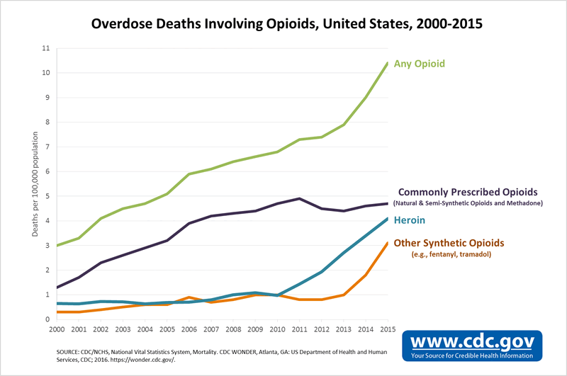
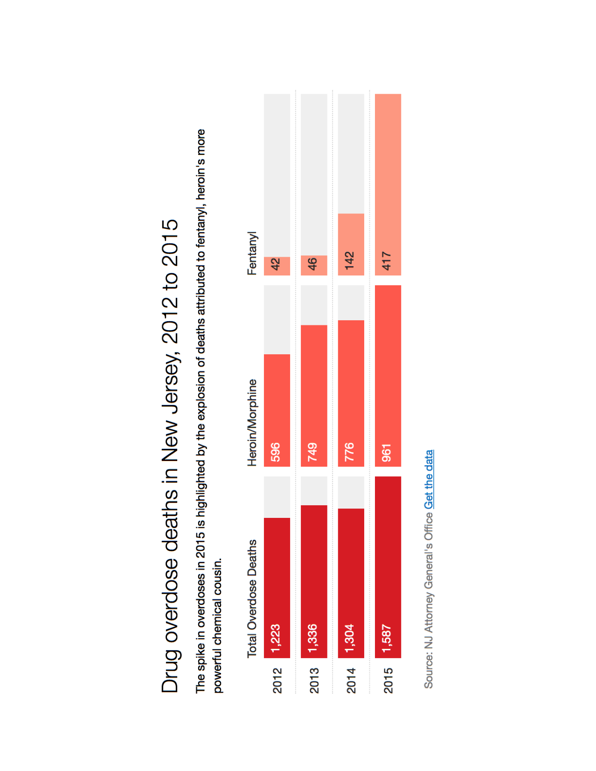

Opioids are derivatives of the morphine molecule and prescribed to reduce pain. An “opiate” is a natural derivative of the poppy plant whereas an “opioid” is a synthetic opiate. Today, the term opioid is used to refer to the entire family of opiates including natural, synthetic, or semi-synthetic. Opioids are HIGHLY addictive and are potentially even more addictive if taken during the adolescent years of brain development (up to age 25). Names of these opioid prescription painkillers include morphine, Vicodin, Oxycontin, Percocet, Demerol, codeine, hydrocodone, Lortab, Dilaudid, Lorcet, Norco, methadone (for treatment), Suboxone (for treatment), Fentanyl (highly potent, frequently used in surgery). Heroin is an opioid that is about 50X more potent than the most frequently prescribed painkillers and Fentanyl is 50-100X even more potent than heroin. Opioids works on receptors (μ) in the brain to reduce pain but also suppress the respiratory system, slow the digestive system (constipation), and suppress the immune system. Tolerance develops in the brain after just one dose of an opioid such that higher and higher doses are required to elicit a desired effect. However, the respiratory system does not develop tolerance to opioids at the same rate as the brain. Thus, the higher and higher doses needed for the brain effects are causing greater suppression of the respiratory system. It is this suppression of the respiratory system that causes death with opioid use. Many people who begin abusing prescription painkillers become addicted and eventually turn to illicit heroin and fentanyl because they are significantly less expensive.

Addiction, or Severe Substance Use Disorder (SSUD) as defined by the DSM-V, is a chronic illness that causes significant impairment – health problems, disability, failure to meet major responsibilities at work, school, home. Severe Substance Use Disorder causes changes in brain morphology and chemistry in the reward center (basal ganglia), the negative reinforcement center (the amygdala) and the prefrontal cortex (reasoning, executive function, judgment). These changes “hijack” the brain to such an extent that the user no longer has control over the ability to simply stop using the drug. Alarmingly, SSUD affects about 1 in 10 adult Americans and only about 1 in 9 of those with SSUD seek treatment.

Prescription painkillers

Generally, the Junior Leagues of NJ State Public Affairs Committee advocates for and supports evidence-based initiatives that:

- prevent substance use and abuse
- treat substance use disorder
- educate parents, community, teachers, coaches, physicians, health care workers, medical and dental schools of the problem and solutions (evidence-based) to the problem
- train first responders on the use of Naloxone
- prevent diversion of prescription drugs (i.e. drug take-back programs)

Support of specific legislation will be determined on a bill-by-bill basis.

Squeglia, L.M., et al. Clin EEG Neurosci. 2009 January ; 40(1): 31–38.

