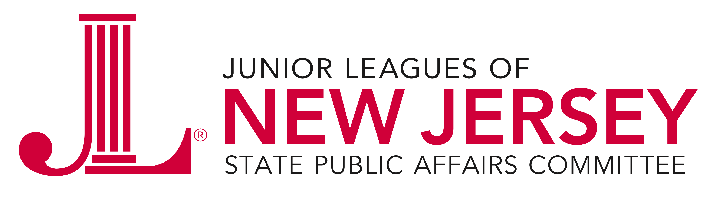
SPAC Meeting Agenda
October 18, 2016 10:00 a.m. – 2:00 p.m.
Jumble Store, Cranford, NJ

10:00 A.M. Call to Order
Approval of September 20, 2016 Minutes

10:05 A.M. Legislative Luncheon Invitations

10:30 A.M. Guest Speakers –
Cecilia Zalkind, President and Chief Executive Officer and
Cynthia Rice, Senior Policy Analyst, Advocates for
Children of New Jersey

12:30 P.M. Lunch

1:00 P.M. Advocacy Event Planning

1:30 P.M. Task Force Chairs – Update and discussion

2:00 P.M. Meeting Concludes

Next SPAC meetings/ Events
November 15th, State House, Trenton, NJ

The Junior League is an international organization of women committed to promoting voluntarism, developing the potential of women and improving communities through effective action and leadership of trained volunteers. Its purpose is exclusively educational and charitable.

